Computer Networks Laboratory Week 9

Name : Tanishq Vyas
SRN : PES1201800125
Section : H
Semester : 5
Branch : CSE

TASK 1

Configurations :

Alice:
IP Address = 2001::02/64
Gateway = 2001::01/64

ROUTER 1 :
Incoming Interface IP = 2001::01/64
OUtgoing Interface IP = 2002::01/64

ROUTER 2 :
Incoming Interface IP = 2003::01/64
OUtgoing Interface1 IP = 2002::02/64

Bob :
IP Address = 2003::02/64
Gateway = 2003::01/64

Routing Table Entries :

Name | Network | Next Hop
Router 2 | 2001::/64 | 2002::01/64
Router 1 | 2003::/64 | 2002::02/64

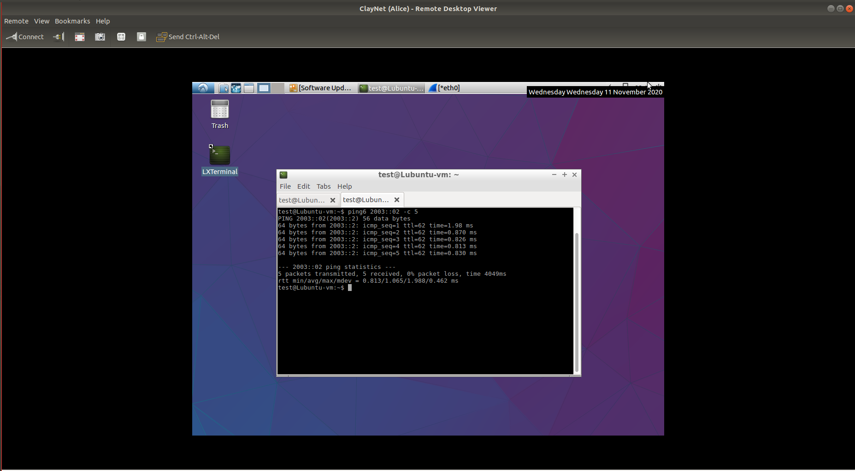
Fig : Terminal Ping Command for Task

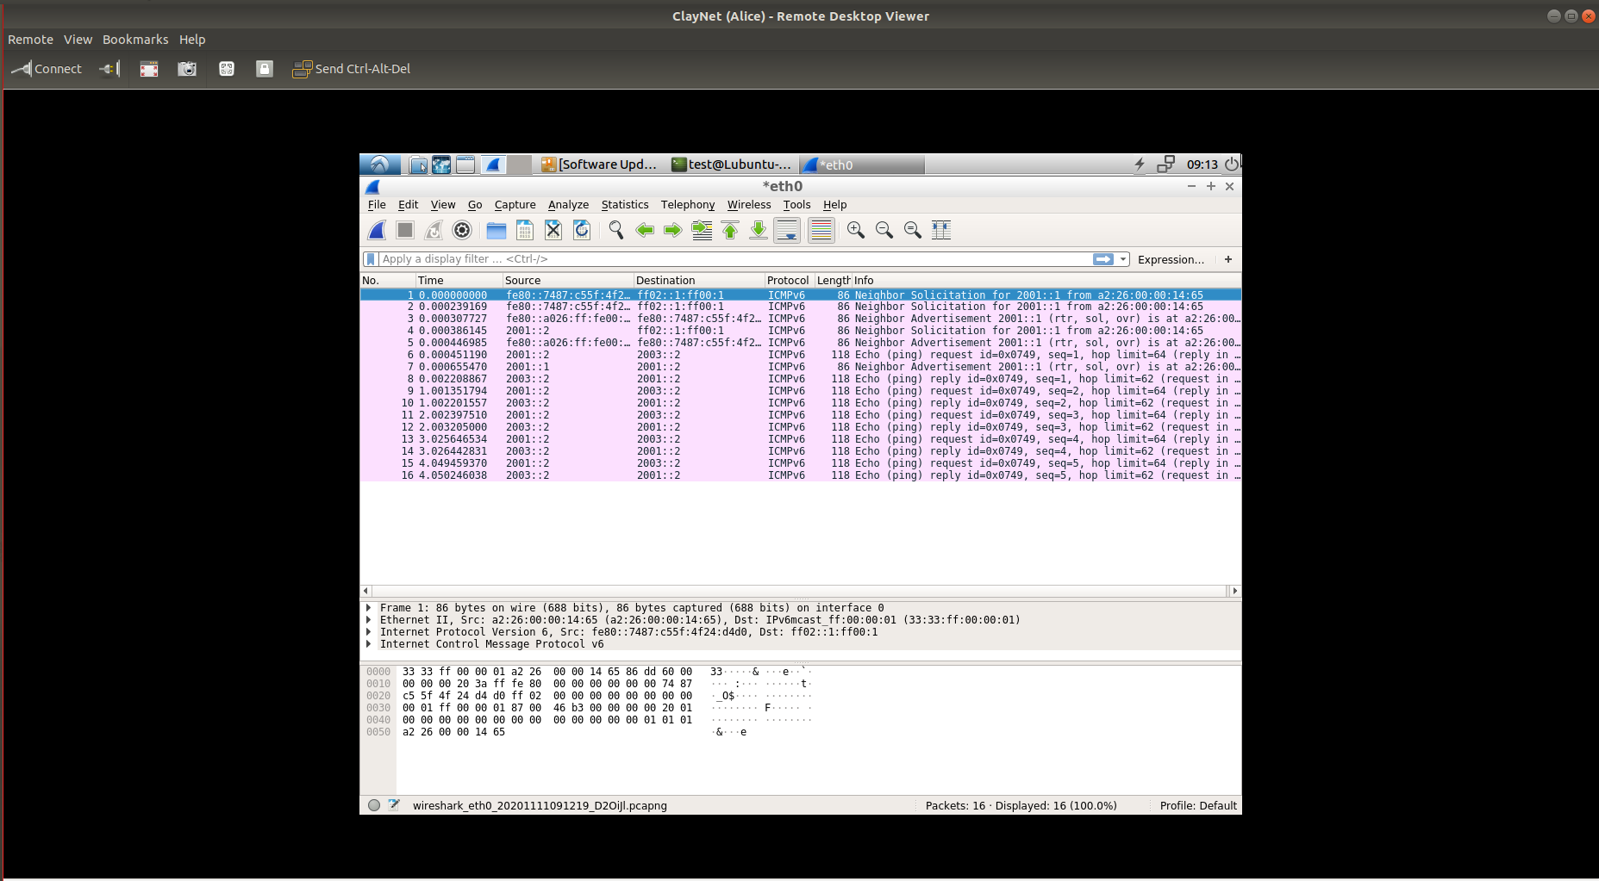
Fig : Wireshark Capture for Task

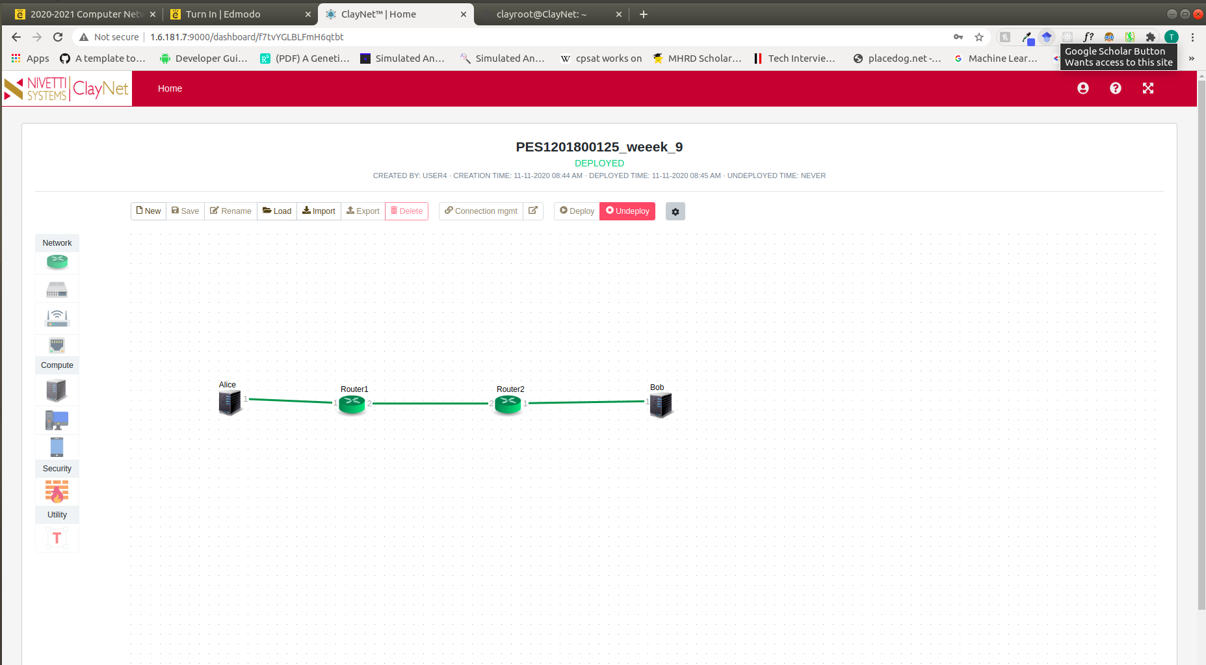
Fig : Topology for Task

